March 1, 2006

To: The State’s Attorney of «County» County

In December of 2005, we sent a letter to all State’s Attorneys in all 102 Illinois Counties requesting information on the number of first degree murders in your jurisdiction since January of 2003. A copy of that letter is enclosed for your convenience.

More than half of all counties have replied, sending their indictments for murder during the period. To date we have not recovered a reply from your county.

Please let us know if we can be of any assistance to you in collecting this information. And please do not hesitate to call if you have any questions about this request.

We very much look forward to hearing from you and to receiving this information.

Please address your response and send copies of the indictments to:

Leigh B. Bienen (312 503-2425)
Northwestern University, School of Law
357 East Chicago Avenue
Chicago, IL 60611

Should you have any questions please call me or any of the other Subcommittee members:
Senator Kirk W. Dillard (630-969-0990)
Thomas P. Sullivan (312-923-2928), and
Michael J. Waller
State’s Attorney of Lake County (847-377-3031)

Sincerely yours,
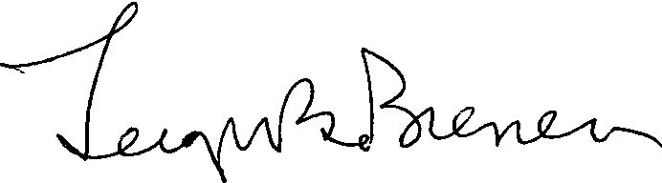
Leigh B. Bienen
Kirk W. Dillard
Thomas P. Sullivan
Michael J. Waller

